Operative Description Calculus: Formalizing Worldtext as an Executable, Auditable Simulation Architecture

Introduction: The Crisis of Generative World Modeling and the Epistemic Void
The rapid acceleration of generative artificial intelligence has yielded systems capable of synthesizing highly convincing, hyper-realistic, and seemingly interactive three-dimensional environments from simple natural language descriptions. Driven by the scaling of large language models, diffusion systems, and neural radiance fields, the threshold for generating cinematic, spatial outputs has effectively collapsed.¹ However, underneath the visual fidelity of these generated worlds lies a profound epistemic and operational crisis: these systems fundamentally operate on a regime of visual plausibility rather than physical or causal validity. They optimize for aesthetic coherence, producing surfaces that mask severe structural underspecification. When these hallucinated environments are utilized as operational proxies—whether for robotic training reinforcement, embodied agentic planning, or spatial computing digital twins—they introduce catastrophic and often silent failure modes. Autonomous agents plan trajectories through doors that exist only as flat texture mappings; objects are generated without collision meshes, mass, or fundamental material properties; and referential identity completely dissolves across simulation time steps as the stochastic nature of generation causes structural drift. The core failure mode of the current generative paradigm is a false equivalence between rendered coherence and executable physical validity.
To address this crisis, a radically new formal system is required: the Operative Description Calculus (ODC). The ODC paradigm treats "worldtext"—the descriptive natural language prompt—not as a direct generator of pixels or polygon meshes, but as an underspecified program requiring typed interpretation, rigorous constraint attachment, formal validation, bounded simulation, and an immutable audit trail. Operating as a prompt compiler with a conscience, ODC deliberately severs the direct text-to-pixel pipeline. Instead, it enforces a layered intermediate representation wherein language must be systematically lowered into explicit geometric, physical, and causal constraints before it can authorize any downstream agent action. The system transforms the worldtext from a mere poem lowered into an intermediate representation into a highly structured simulation contract.
Historically, the concept of embedding text into spatial environments was a rudimentary function of game engines, allowing developers to spawn stationary strings of characters within a 3D coordinate system, such as the point_worldtext entity in the Source Engine or the WorldText modules in Core Games.³ These early instantiations treated text as a passive aesthetic object within a pre-authored world. The Operative Description Calculus inverts this dynamic: the text is the operative genesis of the world. However, because language naturally underdetermines geometry, materiality, and dynamics, ODC must act as the arbiter that detects the exact threshold where semantic interpretation becomes an operationally binding world-structure.
The primary mandate of ODC is to establish a formal liability architecture for world models. It ensures that every actionable affordance within a generated scene can trace its lineage back to a specific entity declaration, a verified spatial relation, a calculated material constraint, and a defined uncertainty bound. By synthesizing principles from formal verification, operational semantics, spatial computing, and probabilistic planning, ODC ensures that environments generated from language are not merely convincing illusions, but formally inspectable, physically constrained, and accountable at every stage of their execution. The research contribution herein is not another generative world model, but the definitive accountability layer for all world models.

The Ancestral Lineage: Tracing the Epochs of Formal Computation
The intellectual architecture of the Operative Description Calculus does not emerge in a vacuum; it is the culmination of nearly a century of distinct computational paradigms. Each historical epoch has contributed a necessary theoretical component to the problem of executable meaning, highlighting the inherent tensions between syntax, semantics, and physical instantiation. Understanding the lineage of ODC requires tracking the migration of meaning across five distinct epochs of formal computation, observing how previous systems grappled with the gap between symbolic representation and spatial reality.

Computational Epoch | Historical Period | Primary Methodologies | Governing Philosophy and Inherent Limitations
Intuition | 1930s–1960s | Turing machines, lambda calculus, automata theory. | Established that computation is fundamentally a symbolic procedure. Meaning was split between syntax and execution. However, these abstract machines lacked expressivity for embodied, spatial worlds and possessed no account of perception or uncertainty.
Formalization | 1960s–1980s | Hoare logic, operational semantics, denotational semantics, type systems. | Introduced the vital concept of accountability for action through preconditions and postconditions.⁵ Taught the lesson that operational safety depends on checking frame conditions. Yet, the static guarantees struggled with the state-space complexity of dynamic environments.
Prototype | 1980s–2000s | Scene graphs, physics engines, entity-component systems, CAD kernels. | Provided the necessary spatial syntax. Worlds were encoded as hierarchical spatial structures and made actionable through numerical integration.⁷ The tension lay between visual fidelity and physical accuracy, relying on brittle, manual asset pipelines.
Optimization | 2000s–2010s | POMDPs, Bayesian networks, reinforcement learning, SLAM. | Tackled action under incomplete knowledge. Probabilistic planning framed action as decision-making under uncertainty.² However, systems suffered from distribution shift, opaque learned representations, and fatal sim-to-real gaps.
Scaling | 2020s | Large language models, diffusion models, neural radiance fields. | Moved language-conditioned synthesis into mass production.¹ Demonstrated that language is highly ambiguous and underdetermines geometry.⁹ Optimized for beauty over structural precision, leading to hallucinated affordances.
The intuition for separating meaning from execution was established early in the twentieth century, yet it remained strictly within the domain of abstract strings and states. The formalization epoch that followed, heavily driven by programming language theory and theorem proving, introduced rigorous checks.⁵ Hoare logic, for instance, demanded that before any state transition (an action) could occur, specific preconditions must be met, guaranteeing postconditions upon termination.⁶ This philosophical stance—that action requires a verified contract—is the beating heart of ODC.
The spatial engine prototype epoch supplied the geometry. Driven by computer graphics and robotics, this period realized that world representation required hierarchical structures like scene graphs and entity-component systems to manage collision, lighting, and behavior.⁷ However, these systems were authored manually; procedural generation lacked semantic grounding. The optimization epoch attempted to automate action within these spaces using advanced probabilistic frameworks like Partially Observable Markov Decision Processes (POMDPs), pushing agents to optimize policies through simulated batches.¹¹
Finally, the generative scaling epoch of the 2020s provided the ultimate interface: natural language. Yet, this interface introduced the most severe blockers to date, including hidden defaults, hallucinated structures, and a total loss of data provenance. The Operative Description Calculus represents the necessary synthesis, the sixth epoch. It acts as a formal bridge uniting the spatial hierarchies of the 1980s, the uncertainty modeling of the 2000s, the syntactic freedom of the 2020s, and the rigorous precondition checking of the 1960s. ODC dictates that interfaces must hide no formal commitments unless their underlying representations are fully inspectable and auditable.

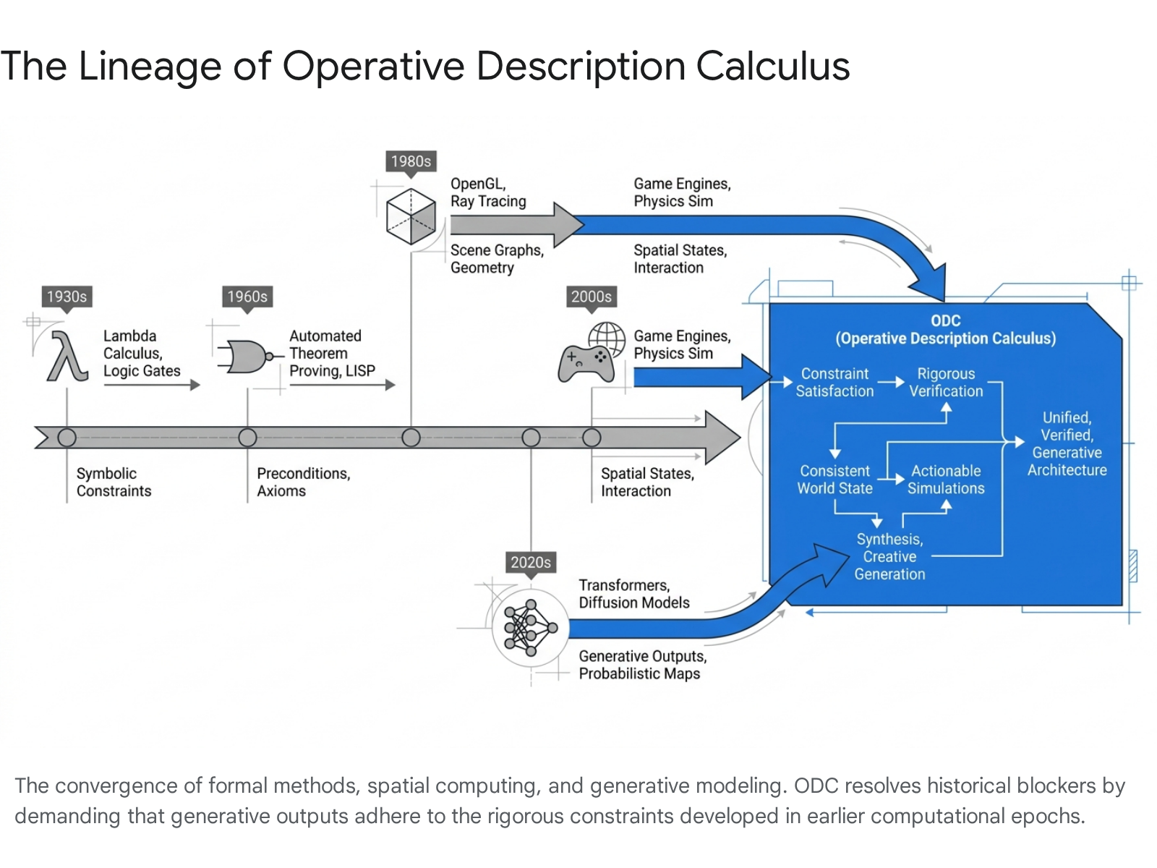

The Migration Map: Executing the Layered Intermediate Representation
To mitigate the inherent ambiguities of generative artificial intelligence, the foundational architecture of ODC relies on a strict decomposition strategy. It explicitly separates semantic interpretation from mechanical execution, visual rendering from physical constraint solving, and model inference from action authorization. To achieve this, a natural language prompt is subjected to a typed pipeline, progressively "lowered" through a sequence of intermediate representations. Each stage in this migration map imposes increasingly strict formal constraints, systematically transitioning the worldtext from a fluid prose string into a legally and physically accountable action space.

Parsing the Semantic Frame: Grounding Language in Prioress
Natural language is fundamentally underspecified. A prompt such as "A service robot grasps the heavy mug on the glass table" implies a vast cascade of unstated physical rules. Direct translation of this phrase to a visual scene risks hallucinating spatial properties that appear visually flawless but fail basic logical assertions.¹ The initial formal shift within the ODC pipeline transforms the raw token string into a structured symbolic parse known as the typed semantic frame.
This semantic frame explicitly exposes the constituent entities (robot, mug, table), their interrelations (on, grasping), their intended actions, and the initial bounds of uncertainty. Semantic normalization at this stage is absolutely critical. The pipeline must extract explicit constraints provided directly by the description while simultaneously leveraging learned common-sense priors to computationally infer implicit pragmatics.⁹ For example, the system must access spatial knowledge representations to infer that a chair typically rests on the floor, or that a glass table must possess the structural integrity to support the mass of a "heavy" mug.¹³ This process captures the statistical occurrence of objects in specific scene types and grounds spatial relation language (e.g., "left," "on top of") into initial geometric boundaries.⁹

The Scene Graph Compilation: From Concept to Spatial Topology
Abstract entities must become spatially organized and relationally bound before any rendering or physical simulation can occur. Therefore, the semantic frame is compiled down into a hierarchical Scene Graph.¹⁰ In modern computer vision and spatial computing, scene graphs are defined as topological structures where discrete nodes represent object bounding boxes accompanied by category labels and attributes, while the edges between nodes represent the pairwise spatial and semantic relationships between those objects.¹⁰
Research originating from spatial computing labs heavily emphasizes that utilizing scene graphs as an intermediate representation drastically improves the reliability and safety of generated environments. Iterative message passing algorithms can be employed on these graphs to jointly infer object categories, precise locations, and relationships, continuously refining the world model.⁷ Frameworks such as Scenethesis demonstrate this by employing vision-guided layout refinement over LLM-generated drafts, explicitly extracting structural elements to capture inter-object relations and prevent unnatural, intersecting object placements.¹ Similarly, the VeriGraph framework has proven that extracting a structured scene graph enables explicit constraint validation during task planning, significantly outperforming baseline language-only methods by guaranteeing that generated action sequences respect the topological reality of the space.¹⁸

Generating the Constraint Graph: Enforcing Physical Contracts
A static, topological scene graph remains insufficient for embodied action. The entities visible within the graph require scale, defined material properties, impenetrable collision meshes, and dynamic affordances to interact with a physics engine. The next formal shift translates the visible object topology into an executable physical contract via a constraint graph.
Every single node in the generated scene graph must be tightly bound to this constraint graph. Within ODC, an object is strictly forbidden from authorizing interaction without declared bounds of uncertainty regarding its mass, friction coefficient, and collision geometry. If a generative language model hallucinates a doorway, the constraint graph validator will aggressively flag the entity if it lacks a defined hinge constraint, a solid non-permeable collision mesh, and an explicit open/close affordance lattice. The visual plausibility of the beautifully rendered wooden door is entirely subordinated to its structural and mechanical precision. Aesthetic generation is halted until the constraint solver can propagate consistent physical values across the graph, mitigating conflicts and establishing an equilibrium of physical laws.⁸

Simulation State Machine and the Agent Action Gate
Actionable worlds require time-indexed transitions. The static constraint graph must be subjected to a physics engine and rigorous operational semantics, transforming the architecture into a dynamic Simulation State Machine.¹⁹ The active simulation must ruthlessly respect the invariants dictated by the constraint graph.⁸ This is the phase where the constructed world is effectively "turned on," and referential integrity must be tracked meticulously across sequential time steps. A background object generated from the prompt must maintain its exact identity, mass, and physical properties even when it exits the primary visual frame of the observer or agent.
Because physics simulation inherently involves numerical approximation, and the foundational generative models inevitably inject degrees of uncertainty, the ODC system must ultimately act as an uncompromising agent action gate. Embodied planning must be systematically blocked, throttled, or heavily qualified when the calculated world uncertainty exceeds predefined safety bounds. By integrating action authorization gates, planning frameworks evaluate whether the agent possesses a verified affordance to execute a maneuver.² If a robotic agent formulates a plan to place a high-mass object onto a surface that the constraint graph identifies as highly uncertain—such as a hallucinated, unsupported floating shelf—the action gate instantly denies authorization, emitting a detailed failure report back up the pipeline.

Formalizing Space: Separation Logic and Simulation Contracts
A paramount theoretical innovation of the Operative Description Calculus is the radical application of program verification techniques—specifically Hoare logic and Separation Logic—directly to three-dimensional spatial environments and kinematic physical simulation.²⁰ Historically, Hoare logic was utilized almost exclusively to reason about software state memory, utilizing classical formal triples . In this framework, executing a specific command from an initial state satisfying a rigorous precondition mathematically guarantees a resulting state satisfying a defined postcondition .⁵ This axiomatic basis allowed developers to tightly specify what a program was permitted to mutate within a system's memory.
ODC adapts this exact paradigm to cyber-physical systems, heavily leveraging recent mathematical advancements in spatial verification designed for complex robotics and high-risk Computer Numerical Control (CNC) machining.²² In standard simulation-based testing, validating the physical safety of a trajectory requires computationally expensive geometric swept-volume analysis to continuously detect mesh collisions. This traditional approach fundamentally struggles with recursive feasibility in highly dynamic, densely populated environments and cannot provide symbolic, mathematical proofs of safety.²²
To overcome this, ODC utilizes a highly structural "Parser-Prover Handshake" that entirely decouples mechanical machine kinematics from formal logical proofs. The physical, three-dimensional workspace is abstracted and conceptualized as a "Spatial Heap," operating much like a discrete, finite memory resource within a standard computer architecture.²² Every 3D coordinate voxel within the generated world is mapped to a specific occupancy state—such as Tool, Environment, Object, Stock, or Empty. By mathematically treating physical spatial occupancy as a strictly managed logical resource, ODC unlocks the ability to apply Concurrent Separation Logic (CSL) to physical movement.²⁴

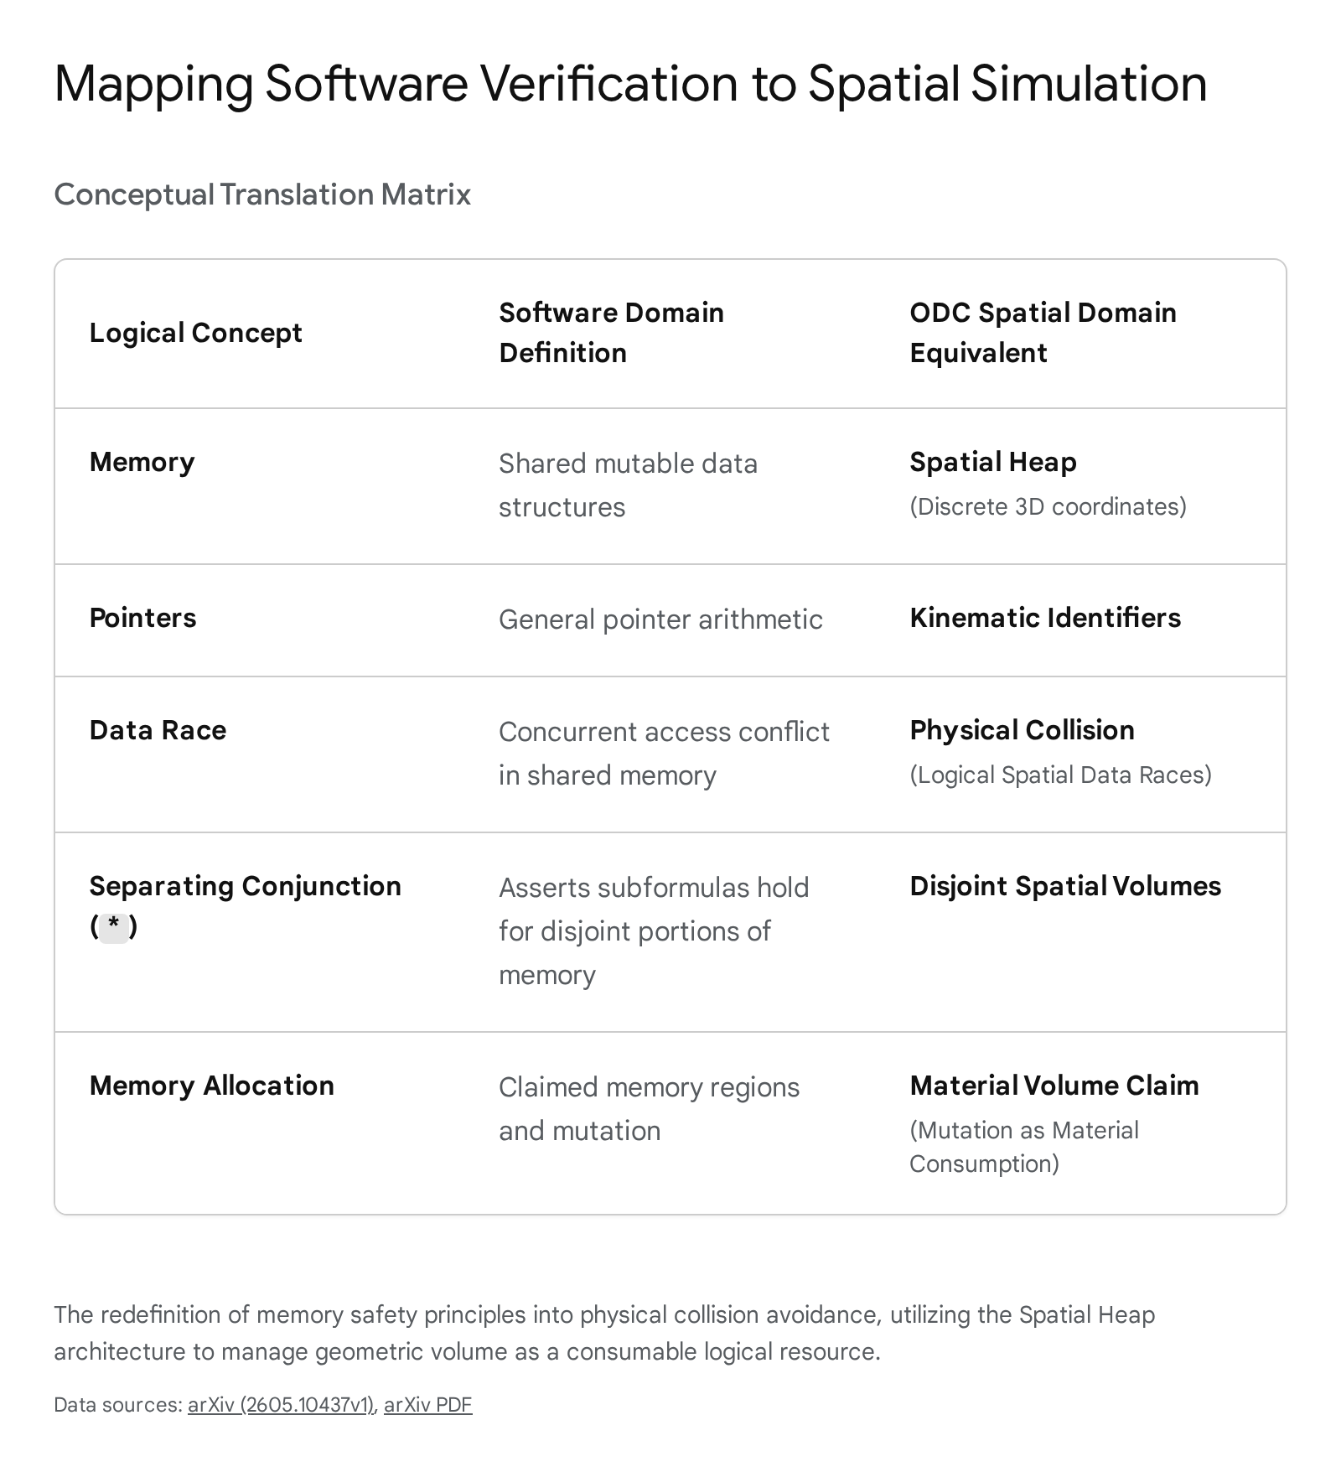

The introduction of the separating conjunction (denoted mathematically as ) is the linchpin of this process. The separating conjunction asserts that its subformulas hold true for absolutely disjoint portions of memory—or, translated to ODC, completely disjoint regions of physical space.²² This allows ODC to formally redefine a physical collision. A collision is no longer merely a geometric intersection evaluated post-movement; it is fundamentally categorized as a Spatial Data Race.²²
If an agent attempts an action (such as extending a robotic manipulator through a generated space), the system generates a formal spatial assertion predicting the required volume. To account for kinematic uncertainty during rapid multi-axis travel, ODC employs a bounding volume approximation utilizing the Chebyshev norm, generating a worst-case Cartesian bounding box of all intermediate coordinates.²⁵ The action can only be verified, and therefore executed, if the separating conjunction establishes absolute, mathematically proven disjointness between the volume claimed by the agent and the volume occupied by the environment.²² If the separation logic fails to join overlapping spatial domains, a collision is formally proven to be inevitable before a single pixel is rendered or a servo motor is actuated.²²
This architectural framework enforces "Safety as a Gateway." Geometric calculation is decoupled from logical execution, ensuring that the Prover dictates deterministic updates without dynamically querying the unverified simulation state.²² The logic evaluates the spatial data race, and the agent's action is either explicitly authorized or blocked based on a mathematically grounded proof, rather than a stochastic or probabilistic collision check.²² Furthermore, ODC heavily relies on the Frame Rule, allowing the system to focus exclusively on the tool's immediate swept volume while protecting the overall workspace's spatial invariance.²² This provides a scalable, declarative alternative to continuous geometric simulation, allowing ODC to treat language-generated worlds as solvable, mathematically provable constraint sets rather than opaque, dangerous 3D mesh models.

Agent Action Gating and Planning Under Partial Observability
In the paradigm of generative world modeling, environments are inherently open-world and deeply uncertain. Even with a verified scene graph, a fully populated constraint graph, and an active physics simulation, an autonomous agent acting within that generated world constantly faces partial observability. The LLM that originally authored the worldtext may have implied object properties, occlusions, or spatial layouts that cannot be fully localized or instantaneously verified by the agent's sensors. Therefore, the Operative Description Calculus relies heavily on advanced probabilistic planning mechanisms, particularly Partially Observable Markov Decision Processes (POMDPs), to safely manage agent actions.²⁶
Traditional POMDP models provide a highly principled framework for decision-making under uncertainty. A POMDP is formally defined by a 7-tuple: , representing states, actions, observations, transition models, observation models, reward functions, and the initial belief over states.² However, these traditional models require full, explicit specifications of all states and actions, severely limiting them to "closed-domain" problems.²
Modern approaches, which ODC integrates into its action gating layer, combine the open-vocabulary commonsense reasoning of Large Language Models with the rigorous Bayesian filtering of POMDPs.² ODC utilizes hybrid planner architectures akin to Tru-POMDP to manage this complexity.² When the description compiler generates a world, and an agent must act within it, the system systematically constructs a hierarchical "Tree of Hypotheses" regarding possible world states, hidden geometries, and missing constraints.²
For instance, if the prompt describes "a cluttered kitchen environment containing a ceramic mug," the agent cannot assume perfect knowledge of the mug's exact coordinates or orientation due to visual occlusion or generative ambiguity. The system instead holds multiple hypotheses—perhaps the mug is on the counter, or hidden inside a specific generated cabinet. These distinct hypotheses form a complex "particle belief state".¹¹
The ODC action gate then dynamically constructs a highly compact, tractable action space based specifically on this belief state. Rather than attempting to query an infinite, open-ended action space (which leads to state explosion and planner paralysis), it extracts relevant entities from the belief particles to create grounded actions. If the belief particles suggest the mug is in a closed area, the dynamic action set generates an explicit affordance to OPEN that specific area, or to PICK a visible target.¹¹
A recursive belief tree search is then executed, simulating future action-observation sequences utilizing the ODC transition models. The agent applies Bellman's principle across this sparse belief tree to calculate value estimates, taking actions that maximize expected cumulative reward while aggressively prioritizing operations that reduce excess environmental uncertainty.²
Crucially, within the ODC liability architecture, if the belief particles indicate that a hallucinated or uncertain affordance poses a risk that exceeds the threshold of the formal contract—such as attempting to rest a heavy robotic arm on a generated surface that lacks a verified structural support constraint—the action gate intervenes. Planning is automatically throttled or completely blocked. This mechanism highlights the system's core tenet: agent autonomy must always remain subservient to the strict world uncertainty bounds established by the description compiler.

Adversarial World Fuzzing and Property-Based Testing
To ensure that the constraint graph and the dynamic simulation state maintain their strict invariants under the pressure of continuous execution, the Operative Description Calculus employs adversarial auditing techniques borrowed directly from distributed systems engineering and compiler theory. Specifically, the architecture integrates property-based testing and coverage-guided fuzzing to interrogate the physics engines.²⁷
Traditional unit testing, which relies on an example-based approach, is woefully insufficient for the state explosion inherent in 3D generative physics engines. A developer cannot possibly manually craft failure scenarios or write tests for every potential collision angle, velocity vector, or mass distribution generated by a language model.²⁷ The hard bugs require automated guidance. Property-based testing fundamentally shifts the testing paradigm by defining general properties or logical invariants that the system must consistently uphold, regardless of the input.²⁸
Within ODC, these mandatory invariants include rules such as: every world state must preserve referential integrity across time steps; no generated object may exist without defined scale and collision behavior; and total energy and mass within closed subsystem boundaries must remain conserved unless explicitly altered by prompt semantics. To continuously verify these properties, ODC integrates simulation fuzzers, conceptually similar to frameworks like Antithesis or PHYFU, which operate directly on the forward and backward simulation phases of the physics engines.²⁷
The fuzzer submits massive volumes of structured, random inputs to the system—subtly altering prompt parameters, varying object velocities, or dropping entities from random generated heights—and observes the simulation's response.²⁹ The mechanism that makes this adversarial process efficient is coverage guidance.²⁷ The fuzzer meticulously observes which specific physical code paths, branches, and collision resolution algorithms are executed.
The entire fuzzing loop operates continuously: the system picks an input from its memory, mutates it, runs the target simulation, and checks for new coverage. If an input triggers a novel state or reaches a boundary condition never taken before, it is added to a growing "corpus" and mutated further.²⁷ Instead of blindly brute-forcing the infinite physical parameter space, coverage feedback acts as a precise compass, deliberately steering the simulation toward complex, untested edge cases.²⁷
When the fuzzer discovers a state where an invariant fails—such as detecting a mesh corruption, a numerical instability causing an object to achieve infinite velocity, or a constraint inconsistency allowing two solid virtual objects to physically overlap—the crash acts as a pure, undeniable signal.²⁷ The system immediately halts, and the counterexample search logs the exact deterministic sequence of generated events that caused the physics engine to break.²⁸ This adversarial testing ensures that the ODC simulation prototype heavily favors inspectability over realism. The architecture vastly prefers a crude but mathematically checkable world that fails safely over a beautiful, high-fidelity environment that hides hallucinated, dangerous functionality behind its rendered surface.

The Liability Architecture: Data Provenance and Audit Traces
The terminal, and arguably most crucial, module of the Operative Description Calculus is its comprehensive audit architecture. As generative language models increasingly combine with physical simulators and autonomous agents, the computational pipeline expands drastically, making error attribution exceptionally difficult. This phenomenon is known as the "reality gap," a discrepancy where simulated robotic experience fails to translate to real-world performance.²¹ When a robot fails to execute a task in a simulated generative environment, tracing the error back to its exact origin is a mandatory requirement for both engineering debugging and formal legal liability.³⁰
Without strict architectural controls, debugging becomes impossible. Did the natural language prompt underspecify the environment? Did the LLM hallucinate an entity that didn't belong? Did the spatial compiler fail to attach a proper collision mesh to the scene graph? Did the physics engine exhibit numerical instability during a collision? Or was it an overconfident agent planner acting on false beliefs? To solve this issue of "provenance collapse," ODC mandates strict data provenance coupled with the implementation of FAIR principles (Findability, Accessibility, Interoperability, and Reusability) across the entire system.³⁰
Provenance, within this context, refers to the highly structured, machine-readable information detailing the usage, generation, and attribution of all elements, data points, and configuration files within the simulation pipeline.³¹ ODC treats provenance not as an afterthought confined to final datasets, but as a core requirement integrated directly into the testing processes, ensuring evidence can be reconstructed end-to-end.³⁰
To achieve this, ODC leverages the standardized W3C PROV ontology to create a massive Provenance Directed Acyclic Graph (DAG).³¹ At its core, the PROV metamodel categorizes the world into three elements: entities, activities, and agents. Every generated 3D model, physical constraint, and simulation video trace is logged as an entity. Every prompt parsing event, physics update step, and simulation run is logged as an activity. The LLM, the compiler, and the end-user are all logged as distinct agents.³¹
When a generated world inevitably fails a constraint check, or when an action gate blocks a robotic plan due to high uncertainty, the ODC system automatically queries the Provenance DAG. This allows forensic engineers to reconstruct the exact failure chain using linked metadata and domain-specific vocabularies.³¹
If a background object suddenly becomes an untracked causal actor and breaks a simulation state, the audit trace can instantly, algorithmically identify exactly which semantic frame originally generated the object, what specific material assumptions the compiler assigned to it, and exactly which line of the intermediate representation authorized its physics update. This rigorous tracking transforms the simulation output from a dangerous "black-box" visualization into a provenance-preserving liability chain, creating a transparent and highly detailed risk register for all spatial AI systems.

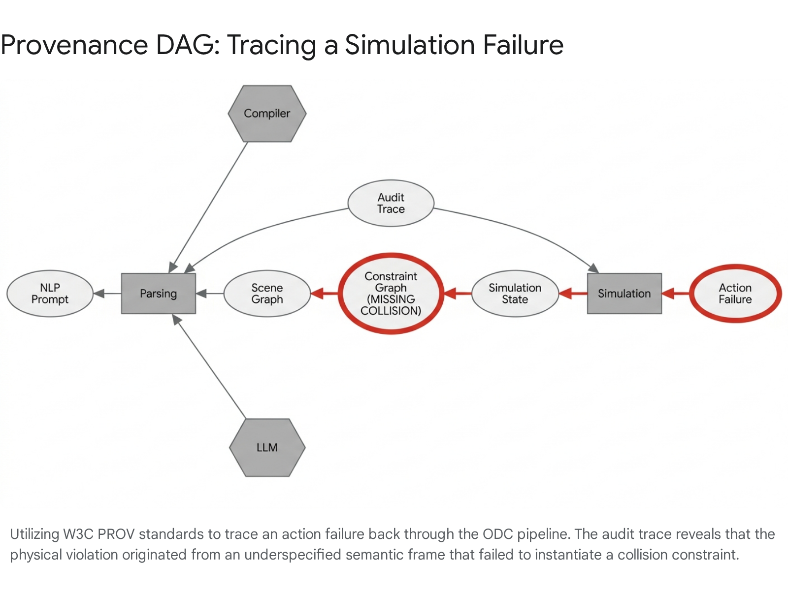

Risk Axis and System Mitigations
The deployment of the Operative Description Calculus is a massive undertaking, and it is not without significant risk vectors. These risks are categorized across formal, computational, epistemic, and usability dimensions, requiring specific architectural mitigation levers to ensure the system remains viable.

Risk Category | Primary Vulnerabilities | ODC Mitigation Levers
Formal Risks | Constraint inconsistency (prompts commanding physically impossible geometries); referential drift across states; unsafe affordance inference. | Implementation of rigid typed schemas; local constraint solvers that reject paradoxical rules before global compilation.
Computational Risks | Severe memory blowup during scene graph expansion; latency collapse during real-time spatial validation; physics engine numerical instability.²² | Incremental validation processing; strict separation of the visual rendering pipeline from the physical constraint pipeline.
Epistemic Risks | Human operators mistaking visual plausibility for physical truth; benchmark gaming; provenance collapse under massive metadata volumes.³⁰ | Mandatory uncertainty visualizations; continuous red-team world fuzzing; domain-specific action throttling.
Usability Risks | Opaque debugging interfaces; high rates of false alarms causing operators to bypass constraints; over-formalization stifling creative workflows. | Human review gates; clear trace logging; providing localized human override capabilities within safe bounds.
The most dangerous systemic threat is the persistence of the very epistemic risk ODC seeks to destroy: the psychological tendency of human operators to trust visually beautiful outputs. Even with ODC enforcing contracts, "audit theater" can occur if the domain-specific validators are poorly authored or too broad. Furthermore, as scenes expand hierarchically, the computational memory required to maintain explicit constraint graphs and separation logic proofs for every voxel and entity can result in rapid latency collapse, threatening real-time interactivity.²²
To manage these vectors, ODC heavily relies on its mitigation levers. Typed schemas ensure data conforms to expected formats long before processing begins. Simulation fuzzers continuously stress-test the environment to discover hardware mismatches and mesh corruptions before an agent ever enters the space.²⁷ Ultimately, if the computational load of verifying a generated scene becomes too high, the system defaults to safety: the action gate lowers, the simulation halts, and the audit log requests human intervention, firmly establishing that physical validity will never be sacrificed for rendering speed.

Conclusion
The transition from purely text-based outputs to multimodal generative world models represents a profound, irrevocable shift in human-computer interaction and spatial computing. We are rapidly moving away from generating static text documents toward spawning dynamic, interactive, three-dimensional physical environments on demand. However, without a rigorous formal architecture to structurally ground these environments, the industry risks building an ecosystem of highly convincing but operationally hollow digital twins—environments that look perfect but lack the fundamental laws of physics required for safe robotic interaction and autonomous planning.
The Operative Description Calculus introduces the necessary, deliberate friction into this generative process. By treating worldtext not as a prompt for an image, but as a formal system—requiring explicit, traceable traversal through semantic frames, scene graphs, spatial constraint validations, and fuzz-tested simulation engines—ODC ensures that every generated artifact maintains both referential integrity and strict physical plausibility.
It fundamentally changes the engineering culture from one of expressive, unconstrained aesthetic generation into one of deliberate, inspectable world construction. By demanding that every visual element carries a corresponding, verifiable physical contract, by tracking every spatial data race through separation logic, and by logging every affordance through an unbreakable provenance DAG, the Operative Description Calculus provides the foundational liability architecture absolutely required for the future of safe, agent-driven spatial computing.

Works cited
- Scenethesis: A Language and Vision Agentic Framework for 3D Scene Generation - arXiv, accessed June 4, 2026, https://arxiv.org/html/2505.02836v1
- Task Planning Under Uncertainty via Tree of Hypotheses and Open-Ended POMDPs - Advances in Neural Information Processing Systems, accessed June 4, 2026, https://proceedings.neurips.cc/paper_files/paper/2025/file/4fb6b4482e4e24a33a3de5b01a011eb0-Paper-Conference.pdf
- point_worldtext - Valve Developer Community, accessed June 4, 2026, https://developer.valvesoftware.com/wiki/Point_worldtext
- WorldText - Core Documentation, accessed June 4, 2026, https://docs.coregames.com/api/worldtext/
- arXiv:2210.17163v1 [cs.LO] 31 Oct 2022, accessed June 4, 2026, https://arxiv.org/pdf/2210.17163
- (PDF) Hoare type theory, polymorphism and separation - ResearchGate, accessed June 4, 2026, https://www.researchgate.net/publication/220676437_Hoare_type_theory_polymorphism_and_separation
- Danfei Xu - Georgia Tech, accessed June 4, 2026, https://faculty.cc.gatech.edu/~danfei/
- Non-Physical Simulation of Gears and Modifiable Connections in Virtual Reality - Uni Bielefeld, accessed June 4, 2026, https://pub.uni-bielefeld.de/download/2610808/2649387
- Text to 3D scene generation | Stanford Digital Repository, accessed June 4, 2026, https://purl.stanford.edu/vg064sy5087
- ChocoWu/Awesome-Scene-Graph-Generation - GitHub, accessed June 4, 2026, https://github.com/ChocoWu/Awesome-Scene-Graph-Generation
- Task Planning Under Uncertainty via Tree of Hypotheses and Open-Ended POMDPs - arXiv, accessed June 4, 2026, https://arxiv.org/html/2506.02860v1
- Online Decision-Making for Scalable Autonomous Systems - IJCAI, accessed June 4, 2026, https://www.ijcai.org/proceedings/2017/0664.pdf
- Learning Spatial Knowledge for Text to 3D Scene Generation - Stanford NLP Group, accessed June 4, 2026, https://nlp.stanford.edu/pubs/spatial-emnlp2014.pdf
- Learning Spatial Knowledge for Text to 3D Scene Generation - ACL Anthology, accessed June 4, 2026, https://aclanthology.org/D14-1217.pdf
- Scene Graph Generation and its Application in Robotics | by Ritanshi Agarwal - Medium, accessed June 4, 2026, https://medium.com/data-science/scene-graph-generation-and-its-application-in-robotics-f9ba864aa572
- Scene Graph Representation and Learning - Stanford Computer Science, accessed June 4, 2026, https://cs.stanford.edu/people/ranjaykrishna/sgrl/index.html
- Scene Graph Representation and Learning, accessed June 4, 2026, https://deeplearning.lipingyang.org/wp-content/uploads/2019/07/ICCV2019_Workshop_Scene-Graph-Representation-and-Learning.pdf
- VeriGraph: Scene Graphs for Execution Verifiable Robot Planning - arXiv, accessed June 4, 2026, https://arxiv.org/html/2411.10446v3
- A Structural Approach to Operational Semantics - LIX (Polytechnique), accessed June 4, 2026, https://www.lix.polytechnique.fr/~fvalenci/papers/sos.pdf
- Your Simulation Runs but Solves the Wrong Physics: PDE-Grounded Intent Verification for LLM-Generated Multiphysics Simulation Code - arXiv, accessed June 4, 2026, https://arxiv.org/html/2605.09360v1
- Probabilistic Semantics for RoboChart - University of York, accessed June 4, 2026, https://www-users.york.ac.uk/~alcc500/publications/papers/WCFMY19.pdf
- Separation Logic for Verifying Physical Collisions of CNC Programs - arXiv, accessed June 4, 2026, https://arxiv.org/html/2605.10437v1
- [2605.10437] Separation Logic for Verifying Physical Collisions of CNC Programs - arXiv, accessed June 4, 2026, https://arxiv.org/abs/2605.10437
- An Introduction to Separation Logic (Preliminary Draft), accessed June 4, 2026, https://www.cs.cmu.edu/~jcr/copenhagen08.pdf
- Separation Logic for Verifying Physical Collisions of CNC Programs - arXiv, accessed June 4, 2026, https://arxiv.org/pdf/2605.10437
- Act to See and See to Act: POMDP Planning for Objects Search in Clutter - AdaComp@NUS, accessed June 4, 2026, https://adacomp.org/wp-content/uploads/2016/08/iros16.pdf
- Diving Into Coverage-Guided Fuzzing - Pierre Zemb's Blog, accessed June 4, 2026, https://pierrezemb.fr/posts/diving-into-coverage-guided-fuzzing/
- Property-based testing - how it works and when to use it - Antithesis, accessed June 4, 2026, https://antithesis.com/docs/resources/property_based_testing/
- PHYFU: Fuzzing Modern Physics Simulation Engines - arXiv, accessed June 4, 2026, https://arxiv.org/pdf/2307.10818
- [2605.29973] Replicable Simulation-Based Robot Validation through Provenance - arXiv, accessed June 4, 2026, https://arxiv.org/abs/2605.29973
- Replicable Simulation-Based Robot Validation through Provenance - arXiv, accessed June 4, 2026, https://arxiv.org/html/2605.29973v1
- Replicable Simulation-Based Robot Validation through Provenance - ResearchGate, accessed June 4, 2026, https://www.researchgate.net/publication/405428351_Replicable_Simulation-Based_Robot_Validation_through_Provenance

